

**EE4216 Hardware for Internet of Things**

Lab2

**Men Jiying**

**A0239631A**

### 1. Introduction

The objectives of this lab are:

* Interface with various sensors including DHT22, light sensor, and HC-SR04, and a relay module.
* Calibrate sensor readings and ensure accurate measurements.
* Display sensor data in the serial port terminal.

This report will document the steps taken to achieve these goals, along with design schematics, code, and results.

### 2. Materials and Setup

### Materials Used:

* ESP32-S3 devkit board
* DHT22 sensor
* Light sensor
* HC-SR04 ultrasonic sensor
* Relay module
* Resistors (10KΩ, 1KΩ)
* Red LED diode
* Breadboard, Dupont wires, and USB cable

### Circuit Design:

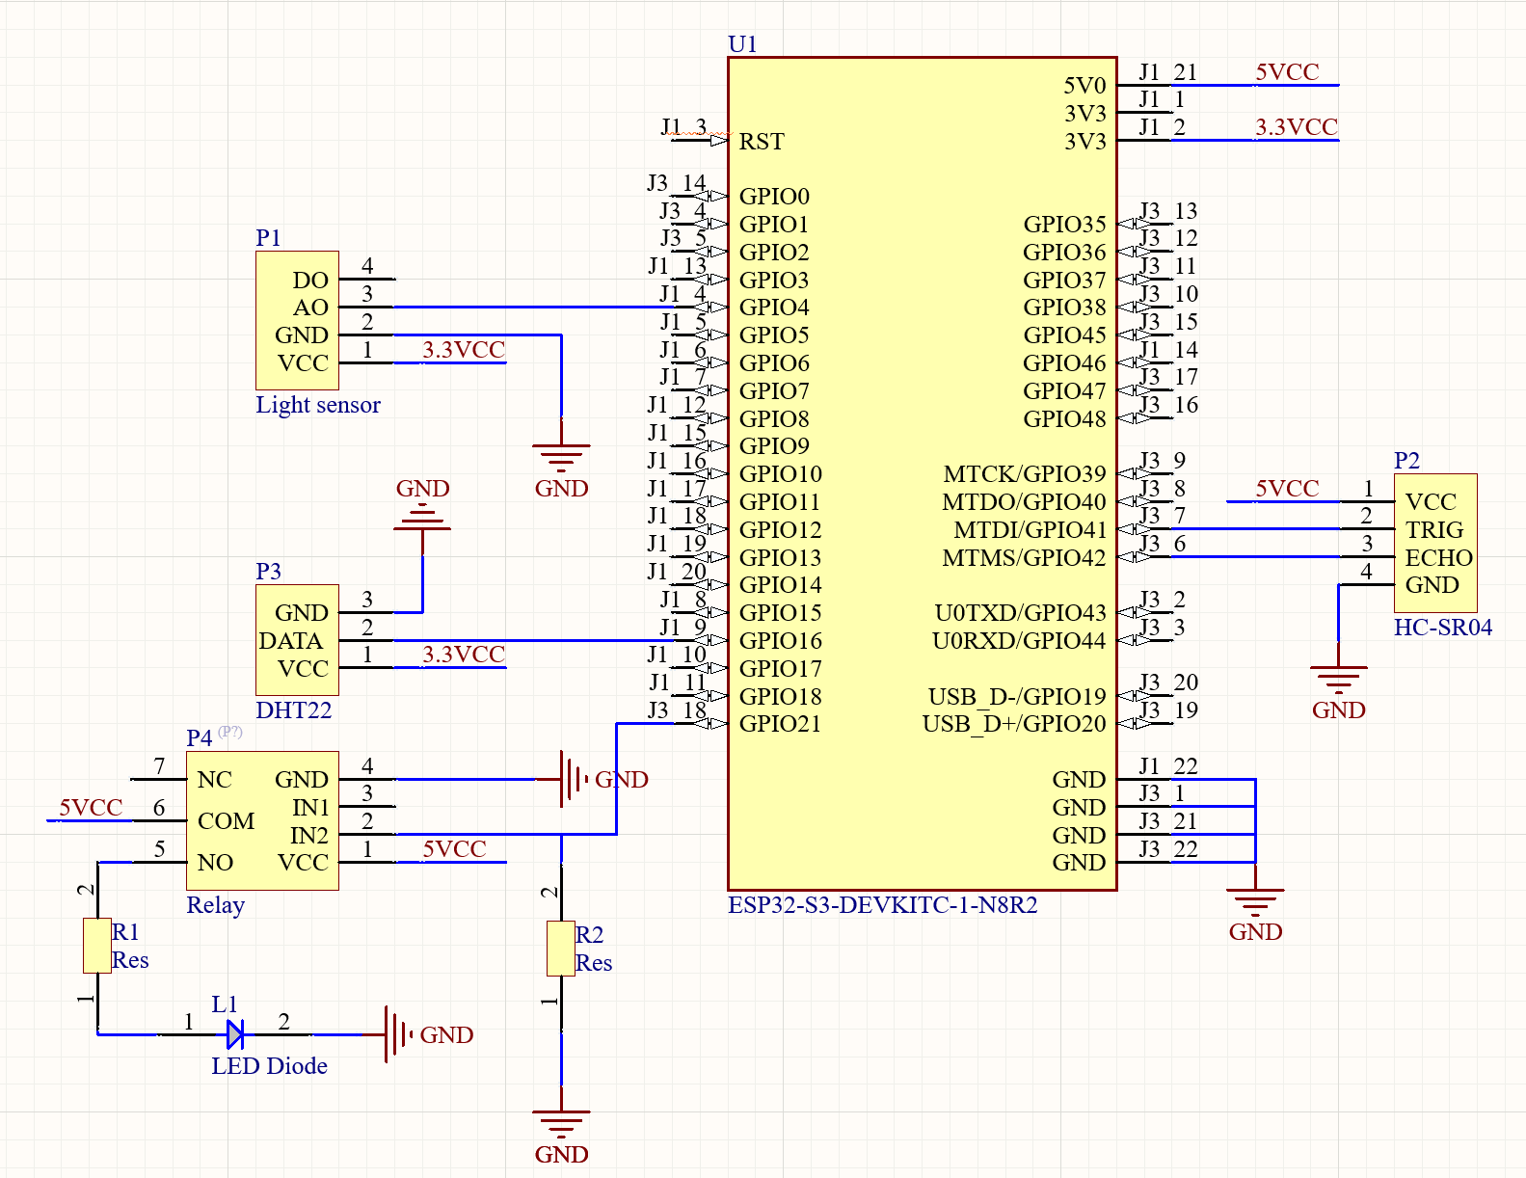

### 3. Lab Activities

### 3.1. HC-SR04 Ultrasonic Sensor

* Objective: Measure distance using the HC-SR04 ultrasonic sensor and ESP32-S3.
* Code:

#define TRIG_PIN 41 // Trigger pin for HC-SR04

#define ECHO_PIN 42 // Echo pin for HC-SR04

// Variables for calibration

float calibration_factor = 1.05; // calibrated factor with 0.5cm precision

void setup() {

Serial.begin(115200);

pinMode(TRIG_PIN, OUTPUT);

pinMode(ECHO_PIN, INPUT);

}

float measureDistance() {

// Send a 10us pulse to the trigger pin

digitalWrite(TRIG_PIN, LOW);

delayMicroseconds(2);

digitalWrite(TRIG_PIN, HIGH);

delayMicroseconds(10);

digitalWrite(TRIG_PIN, LOW);

// Measure the time for the echo pulse

long duration = pulseIn(ECHO_PIN, HIGH);

// Calculate distance in cm (speed of sound is 343m/s)

float distance = (duration * 0.034) / 2;

// Apply calibration factor

distance *= calibration_factor;

return distance;

}

void loop() {

float distance = measureDistance();

Serial.print("Measured Distance: ");

Serial.print(distance);

Serial.println(" cm");

delay(1000); // Delay 1 second between measurements

}

* Code Results

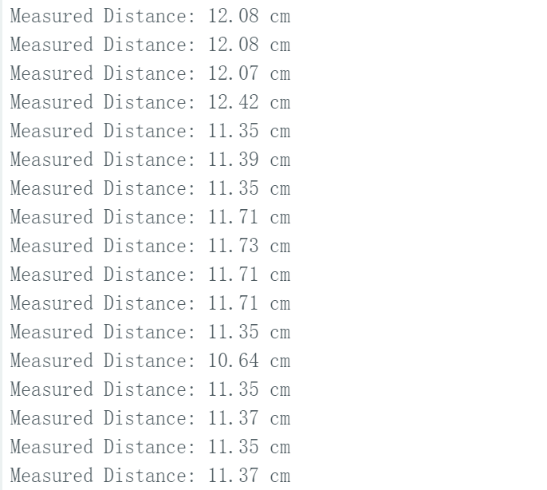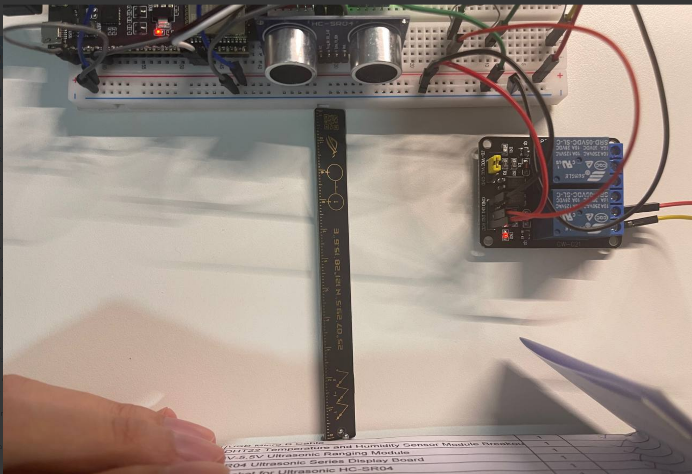

### 3.2. Relay Module and LED Control Integrated with Light Sensor and DHT22

* Objective: Control the relay module to turn on/off the red LED based on room illumination, Meanwhile update humidity and temperature data every 5s and on demand.
* Code:

#include <Adafruit_Sensor.h>

#include <DHT.h>

// Define sensor and relay pins

#define DHTPIN 16

#define DHTTYPE DHT22

#define LIGHT_SENSOR_ANAPIN 4

#define RELAY_PIN 21

DHT dht(DHTPIN, DHTTYPE);

// Timer variables

unsigned long previousMillis = 0; // Stores the last time temperature was updated

const long interval = 5000; // Interval at which to read temperature (5 seconds)

void setup() {

Serial.begin(115200);

dht.begin();

pinMode(RELAY_PIN, OUTPUT);

}

void loop() {

unsigned long currentMillis = millis(); // Current time

// Read the light sensor and control the relay (respond immediately)

int lightValue = analogRead(LIGHT_SENSOR_ANAPIN);

// Immediately control relay based on light conditions

if (lightValue < 500) {

digitalWrite(RELAY_PIN, HIGH); // Turn on relay if low light detected

} else {

digitalWrite(RELAY_PIN, LOW); // Turn off relay if high light detected

}

// Read humidity, temperature, and light values every 5 seconds

if (currentMillis - previousMillis >= interval) {

previousMillis = currentMillis;

float humidity = dht.readHumidity();

float temperature = dht.readTemperature()+ temperatureOffset;

if (isnan(humidity) || isnan(temperature)) {

Serial.println(F("Failed to read from DHT sensor!"));

} else {

float heatIndex = dht.computeHeatIndex(temperature, humidity, false);

// Update the sensor data

Serial.print("Humidity: ");

Serial.print(humidity);

Serial.print(" %\t Temperature: ");

Serial.print(temperature);

Serial.println(" °C");

}

// Print the light sensor values every 5 seconds

Serial.print("Analog Light Value: ");

Serial.println(lightValue);

}

// Check for request to display temperature on demand

if (Serial.available() > 0) {

String request = Serial.readString();

request.trim(); // Remove any extra spaces or newline characters

if (request == "temperature") {

float temperature = dht.readTemperature()+ temperatureOffset;

Serial.print(F("Current Temperature: "));

Serial.print(temperature);

Serial.println(F("°C"));

}

}

}

* Code Results

